Cash out Policy Reminders (Instructions on completing the online form follow):
- You can only cash out up to one week’s standard hours, no matter how much PTO you have accrued.

- You must have at least two week’s standard hours remaining in your account AFTER the cash out. Example, a 40 hour per week employee would need to have 120 hours accrued in their PTO account to be able to take the maximum of 40 hours cash out.

- You do not have to cash out the maximum amount, you can cash out less (in hourly increments) or you do not have to cash out at all.

- Some staff can only cash out one week’s standard hours per fiscal year (July-June). This does not mean you cannot participate in both cash out periods (November and May) but you would need to divide the hours between those 2 periods. Most Direct Care staff can cash out one week’s standard hours at both cash out periods. Since the November cash out is the first cash out period of the fiscal year, all full time employees with enough PTO are eligible. For the May cash out, those who do not have a job title that allows the additional week may not be able to cash out if they have already taken the week in October.

List of job titles approved for 5 days at EACH cash out:

- Childcare Worker – (Day, Night)
- Community Consultant
- Community Connection Coach
- Direct Support Professional – (also Non-Driver, Weekend, Extended Leave)
- DSP-Behavioral Health
- DSP-Community Medical Homes (Day, Night, Weekend Day, Weekend Night)
- Driver
- Employment Consultant
- House Parent
- Lead DSP
- Nurse LPN – (Day, Night, Weekend Day, Weekend Night)
- Nurse RN– (Day, Night, Weekend Day, Weekend Night)
- Nurse House Manager
- Staff Scheduling Coordinator
- Universal DSP

Cash Out Form Instructions

All staff eligible for cash-out will receive an email from “KenCrest Cash Out/ Snap Survey” that has a link to complete the online form. This link is unique to each employee.
Note: You are not required to cash-out PTO; if you do not want to cash-out please ignore the automated emails.
The email will look like this in Outlook:
*Note: This form will go to the email address you have in Workday

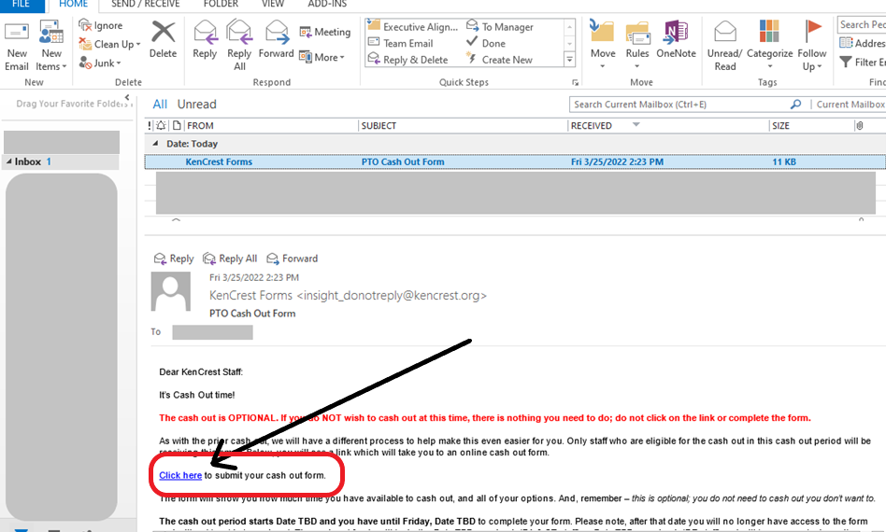
Click the link within the email.

The form will look like this:

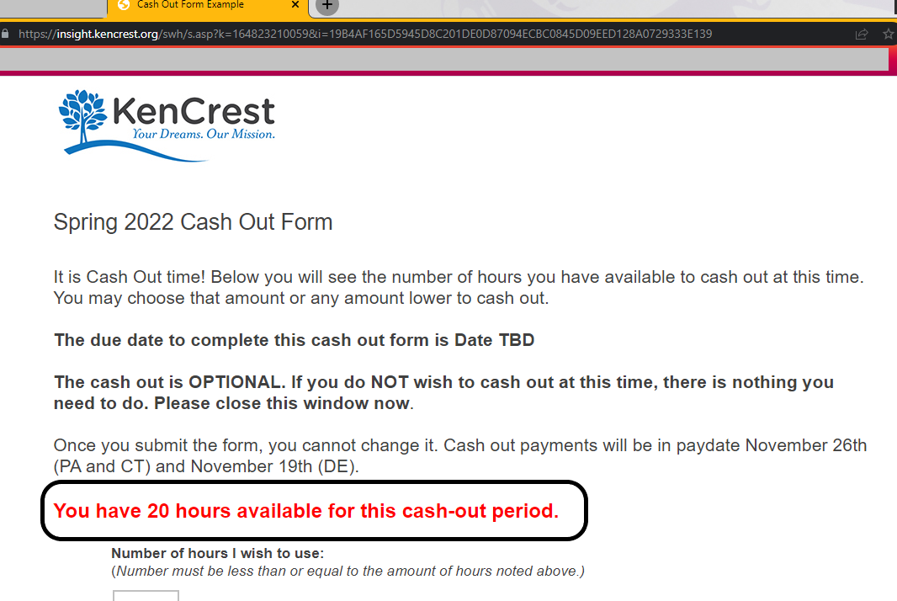

*Note: Dates on example screen shots are for example only. Dates will be determined for each cash-out period and noted in the form you receive.

- Your form will note the number of hours you have available to cash out. (in red on example above)
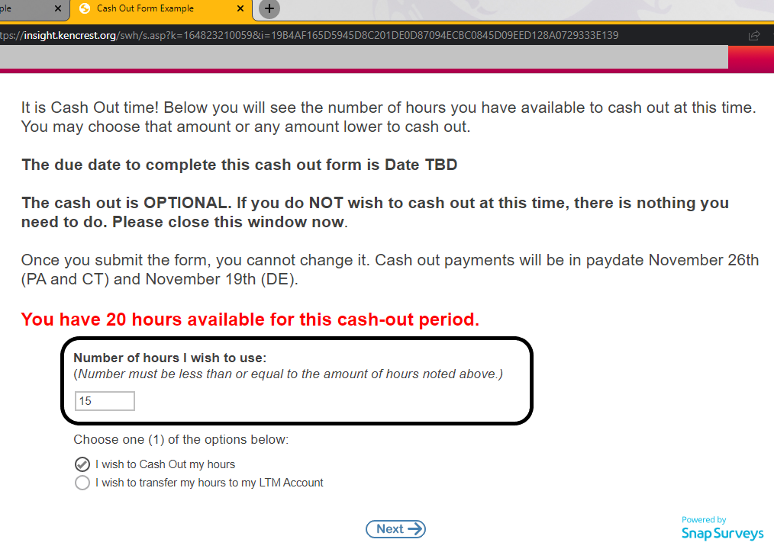

- Type the number of hours that you want to cash out in the box. The number must be less or equal to the number of hours in red text.
- Select one of the options – Cash out hours or Transfer to LTM Account
- Click “Next”

If you select the first option “I wish to Cash out my hours” – it will look like this:
- Make one (1) selection from the available options
- Click “Submit”

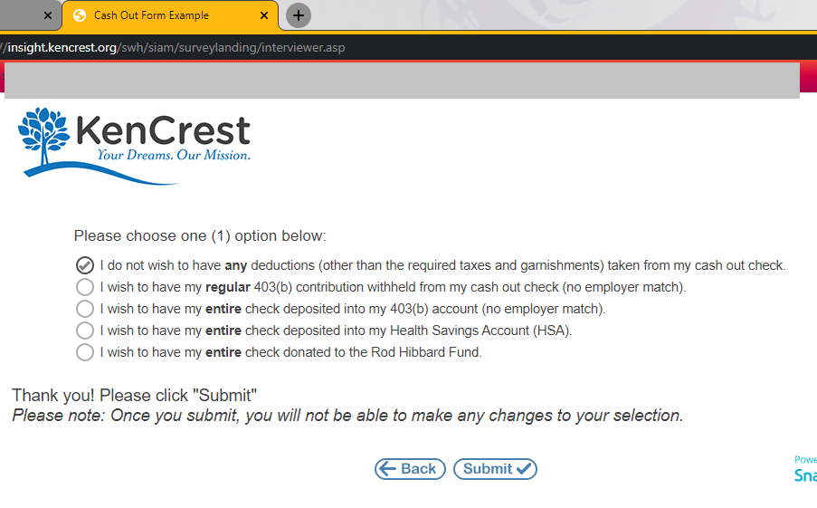

If you select the second option: “I wish to transfer hours to my LTM Account”
- You will be taken to the last page, there are no further questions.
- Click “Submit”

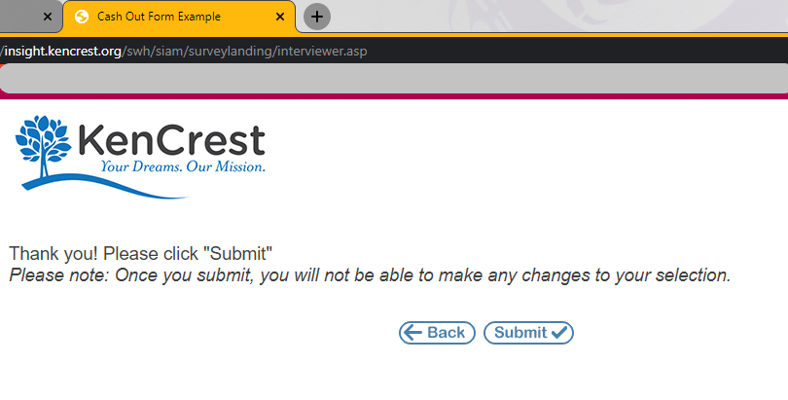

When your form has been successfully submitted, you will be taken to the KenCrest website, main page.

